**Boston police arrest suspect in Dorchester**

**shooting**

**By Travis Andersen** Globe Staff, September 4, 2018, 9:34 a.m.

**4**

Boston police arrested a shooting suspect and seized two guns in Dorchester Monday afternoon, before taking another firearm off the street and nabbing two more men hours later in a separate incident in Charlestown, officials said.

The first arrest took place around 12:24 p.m. Monday, when officers were called to the area of Dorchester Avenue and Centre Street for a person shot, according to a police statement.

“The victim, unable to provide officers with additional information, was then transported to a local hospital with non-life threatening injuries,” the release said. “Officers and detectives on scene located a blood trail which led to a residence in the area.”

Advertisement



Cops found more blood in the vestibule area of the residence, the statement said, and also recovered a “loaded Ravens Arm P25 firearm with a spent shell casing and a Raven Arms MP25 with an obliterated serial number.”

They also got a suspect, identified as Javohn Redrick, 26, of Brockton.

**Get Today's Headlines in your inbox** Enter Email

[example@email.com](mailto:example@email.com)

**Sign Up**

The day's top stories delivered every morning.

He’s now charged with assault with intent to murder, two counts of unlawful possession of a firearm, unlawful possession of ammunition, and firearm discharged within 500 feet of a dwelling, the release said.

Police, meanwhile, were far from finished on Labor Day.

Around 7:35 p.m. Monday, a traffic stop in the area of Medford and Decatur streets in Charlestown resulted in another gun seizure.

Officers had spotted a “motor vehicle with excessive window tints,” police said in a statement, and an “additional traffic infraction allowed officers to conduct a traffic stop. An exit order was issued due to the actions of the operator who appeared to be extremely nervous of the officers’ presence.”

The driver, Lukasz Zajkowski, 33, of Dorchester, allegedly had a weapon.

“Upon exiting the vehicle, officers observed [Zajkowski] to be in possession of a firearm, located in his waistband,” the statement said. “Officers recovered a loaded Walther P99 .40 caliber firearm and ten rounds of live ammunition.”

Advertisement

A passenger wearing a GPS monitoring device, Darien Everett, 36, of Hyde Park, was also arrested for allegedly violating his probation.

Zajkowski faces charges of unlawful possession of a firearm, possession of a loaded firearm, unlawful possession of ammunition, and larceny of a firearm, police said.

[Travis Andersen can be reached at travis.andersen@globe.com. Follow him on Twitter @TAGlobe.](mailto:TravisAndersencanbereachedattravis.andersen@globe.com.FollowhimonTwitter@TAGlobe)

**Show comments**

# BOSTON GLOBE VIDEO

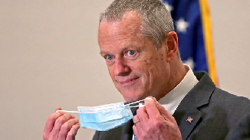

2:23

Baker announces ‘VaxMillions’ lottery program SHARE

Governor Charlie Baker announced residents who are fully vaccinated against COVID-19 will have the chance to win $1 million in a special Lottery sweepstakes. (Photo by Matt Stone/Boston Herald via AP)

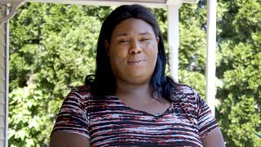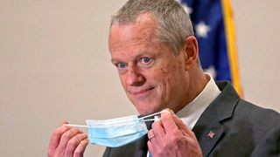

**Baker announces ‘VaxMillions’ lottery program**

**NOW PLAYING**

**Moose spotted on Route 3 in Chelmsford**

**What Black liberation means to me: Athena Vaughn**

SEE MORE VIDEOS

**MOST POPULAR ON BOSTONGLOBE.COM**

1. Life sciences is poised to be Boston’s dominant industry. Has the area become the Silicon Valley of biotech?
2. Some lawmakers want to ban critical race theory in schools. So, what is it?
3. The state’s second-biggest health insurer has a buzzy new name
4. Coolidge Corner Theatre unveils plans for major expansion
5. Is there something wrong with the air in South Portland, Maine?
6. ‘My Name Is Bulger’: Two brothers, one documentary, an only-in-Boston tale
7. The downside of ditching masks: the return of colds, flu
8. How Massachusetts communities are celebrating the state’s first official Juneteenth
9. 12 observations from Patriots minicamp, day 2: Mac Jones impresses among QBs, Jalen Mills stands out
10. Too hot? Sky-high prices may be scaring some buyers away from the housing market



**VIEWS FROM OUR COLUMNISTS**

**YVONNE ABRAHAM**

Energy efficiency is a low-hanging fruit to combat climate change. So why can’t everyone get access to it?

**KEVIN CULLEN**

Bill Bratton on American policing and the challenge facing the Boston Police Department

**THOMAS FARRAGHER**

A salute across the ages to an old squad leader

**SHIRLEY LEUNG**

A working mother’s manifesto: Pandemic provides a once-in-a-generation chance to course correct how we work

**JENEÉ OSTERHELDT**

The pride I carry with me: Karim

**ADRIAN WALKER**

‘The best Boston movie no one’s ever seen’: ‘Blue Hill Avenue’ at 20

**MORE ON GLOBE.COM**

# SPONSORED BY: HARVARD PILGRIM HEALTH CARE

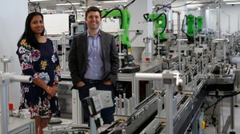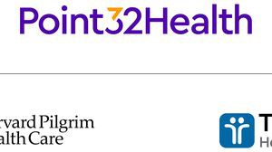

## Parents say they learned these 4 lessons from life in the age of COVID-19

How the pandemic shifted New England parents’ perspectives.

# INNOVATION ECONOMY

## Life sciences is poised to be Boston’s dominant industry. Has the area become the Silicon Valley of biotech?

Since December, you can find six major indications that Boston is the undisputed center of the life sciences industry, a place where ideas and products that change — and save — people’s lives around the world originate.

# THE GREAT DIVIDE

## Some lawmakers want to ban critical race theory in schools. So, what is it?

As national debate over race-related curriculums rages on, here is a lesson on the subject and the controversy surrounding it.

## The state’s second-biggest health insurer has a buzzy new name

Tufts Health Plan and Harvard Pilgrim Health Care merged in January but didn't name the new company they created until Wednesday: Point32Health.

## ‘My Name Is Bulger’: Two brothers, one documentary, an only-in- Boston tale

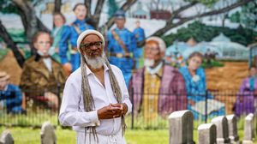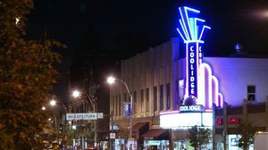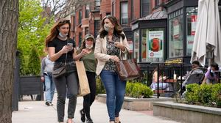

The Discovery+ film offers an unusually intimate view of Whitey and Bill Bulger.

## How Massachusetts communities are celebrating the state’s first official Juneteenth

For more than a century, Juneteenth was a Texan holiday, then a Southern holiday, commemorating the anniversary of June 19, 1865, when General Gordon Granger of the Union Army told formerly enslaved people in Galveston they were free. Now it will be celebrated for the first time across the Commonwealth as an official state holiday.

## Coolidge Corner Theatre unveils plans for major expansion

Brookline officials are reviewing a proposed expansion of the landmark Art Deco cinema that will add two new screens — and over 200 seats — as well as a larger lobby and third-floor community space, with a catering kitchen and outdoor roof deck.

## The downside of ditching masks: the return of colds, flu

Since the state’s mask mandate was lifted, face coverings have started to come off — and stay off. But according to infectious diseases doctors, the return of facial freedom might come with some downsides, like a resurgence in cases of the common cold and the flu.

## Future-proofing the Presidency

Donald Trump brought our democracy to the brink and exposed its weak spots. How to thwart the next American tyrant.

# GLOBE MAGAZINE

## Is there something wrong with the air in South Portland, Maine?

Residents have lived near more than 100 massive petroleum storage tanks for decades, never really knowing if they’re breathing in dangerous chemicals. Now they’re fighting to find out.

**MOST READ IN THIS SECTION**

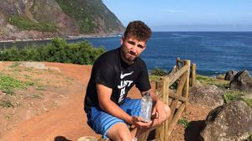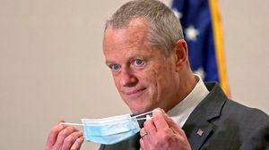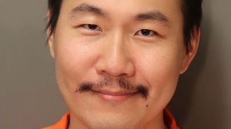

**THE GREAT DIVIDE**

**Some lawmakers want to ban critical race theory in schools. So, what is it?**

**GLOBE MAGAZINE**

**Is there something wrong with the air in South Portland, Maine?**

**RI NEWS**

**Message in a bottle, tossed into the sea in Rhode Island, found in Azores**

**The downside of ditching**

**masks: the return of colds, flu**

**How Massachusetts**

**communities are celebrating the state’s first official Juneteenth**

**Baker announces**

**‘VaxMillions’ lottery program, offering $1 million cash prizes to boost vaccination rates**

**Baker signs bill extending**

**pandemic-era policies, including to-go cocktails, expanded outdoor dining**

**Documents shed new light**

**on case of MIT grad student accused of murder in Connecticut**

# FOLLOW US

**SUBSCRIBE NOW MY ACCOUNT CONTACT MORE**

Digital Access / Home Delivery / Gift Subscriptions

Log In /

Manage My Account / Customer Service

Help & FAQs / Globe Newsroom / Advertise

Newsletters / View The EPaper /

Order Back Issues / News In Education / Search The Archives / Privacy Policy / Terms Of Service / Terms Of Purchase / Work At Boston Globe Media /

Do Not Sell My Personal Information

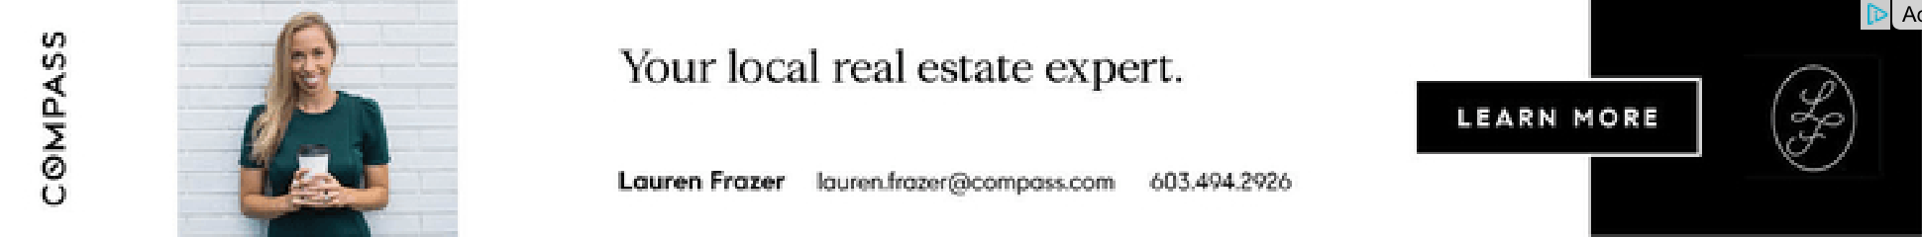

**METRO SPORTS BUSINESS & TECH OPINION**

WELCOME, JOHN

**TODAY'S PAPER**

**Summer Fitness Challenge Starts Monday**

Sign up now

©2021 Boston Globe Media Partners, LLC